Founders’ Intent Task 2 FOUNDERS’ INTENT
AP Gov
Founders’ Intent – Historical Structured Academic Controversy
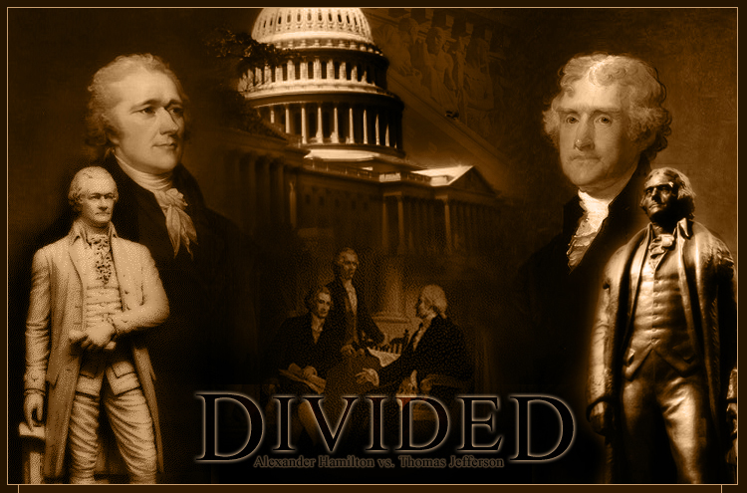
DEBATE ON THE NATIONAL BANK
Should the National Government set up a bank?
Background
When it came to a limited national government, the Federalists and the Anti-federalists did not see eye-to-eye on how much power the federal government should have. One of first issues that required interpreting powers given to the federal government by the newly adopted U.S. Constitution was the infamous debate between Thomas Jefferson and Alexander Hamilton on whether or not the federal government had the power to set up a national bank.
What was the big deal? Let's find out!
The Task
- You will stay in your roles: Delegate to your state’s legislature
- You will be assigned (based on your delegate role) to either the pro (Alexander Hamilton) or con (Thomas Jefferson) positions to the debate.
- You will need to come to a compromise within your group about whether or not the national government should set up the bank.
The Process

- Create your argument by using the information provided + your textbook, the Constitution, etc.

- As you create an argument, use the following questions to guide you through the information:

  - Based on your role, why are you for and/or against the idea of a national bank? (be sure to use the Constitution as the basis for your reasons)

  - What in your background would lead you to believe you would take the position you did?

  - What are your main arguments?

  - How will you refute your opponent's arguments?

- Participate in and complete a structure academic controversy activity in groups

- Write and turn in a position paper outlining why you (as a delegate) have taken the position that you chose on this particular debate

Advice
You must become very familiar with the issues in this debate. However, remember that the controversy is about whether the national government has the power to create a bank. Remember your delegate role and whether your role would want the federal government or the state government to oversee this issue. Be sure to use the Constitution as the basis for your argument and reasoning.

