RESOURCE PACKET: Clerking for SCOTUS

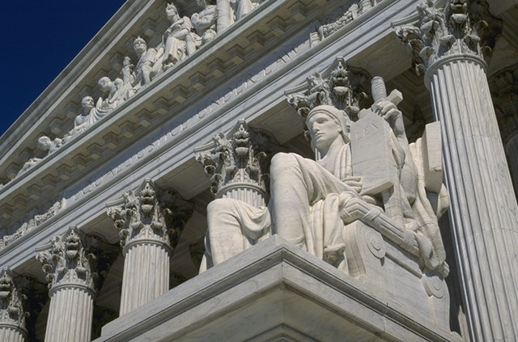
Major Concepts:

1 – Judicial Branch
2 – Checks and Balances
3 – Civil Rights/Civil Liberties

NAME: __________________________________
PERIOD: ____DATE DUE: ______________

CLERKING FOR SCOTUS
While our political traditions have shaped how we view, adopt, and interpret the Constitution, differing applications of the Constitution often requires more formal interpretations of the Constitution. The judicial branch, with its appeals process (especially through SCOTUS), serves as a formal interpreter of the Constitution. Their decisions set precedents for future decisions. However, these precedents can be overturned by new decisions. And since Justices serve lifetime terms, their appointments are contentious political actions.
How do Supreme Court Justices make decisions? How does a court case get to the Supreme Court? How do Supreme Court decisions influence policy making? How can individuals and groups influence Supreme Court decisions?
Project Objectives

Students will understand . . .
- the structure of the judicial system and how it operates
- landmark cases and the Constitutional issues associated with them
- the role that linkage institutions play in the operation of the court and the limits of their influence
- how the court attempts to balance the rights of the individual and the needs of society
- how civil liberties and civil rights have developed through judicial interpretation

Students will learn how to . . .
- analyze the conflict between judicial philosophies (original intent vs. living Constitution)
- use the Constitution and precedent cases as the basis for judicial decision-making

Overview:

The objective of this project is for students to learn how the federal court system of the United States works. Students take on roles as lawyers who are applying to clerk for Supreme Court Justices. In task one, students will show their knowledge of the judicial branch in their application statements. In task two, students are hired to clerk for Justices, where they will research landmark decisions in order to help their new boss make a decision on new hypothetical cases. Through this project, students revisit important constitutional concepts (especially federalism, separation of powers, checks and balances, enumerated/implied powers), at the same time, reviewing the roles that governmental institutions and linkage institutions play in the U.S. political system.
Tasks:
- In the first task, students are applying to be a clerk for a Justice in SCOTUS, where they have to learn about the structures of the judiciary in order to know what their job will entail.
- Students take on roles as clerks to Justices to SCOTUS, students are researching landmark cases in order to provide a brief on hypothetical cases for their Justices.
By the end of the project, students will gain a better understanding of how the U.S. judicial system works and the role that it plays in security our civil liberties.

Resources:

- AMSCO Chapters 7-9 pgs. 189-346
- Quizlet Unit 4 Clerking for SCOTUS: The Judiciary
- Quizlet Unit 4 Clerking for SCOTUS: Civil Rights and Civil Liberties
- Youtube Channel AP Government Unit 4: Clerking for SCOTUS Playlist
Key Concepts Short Answers
LOR-2.A: Explain how the U.S. Constitution protects individual liberties and rights. | Pgs. 234-238
LOR-2.B: Describe the rights protected in the Bill of Rights. | Pgs. 27, 234-235
LOR-2.C: Explain the extent to which the Supreme Court’s interpretation of the First and Second Amendments reflects a commitment to individual liberty. | Pgs. 239-268
LOR-2.D: Explain how the Supreme Court has attempted to balance claims of individual freedom with laws and enforcement procedures that promote public order and safety. | Pgs. 2390242, 24-252, 290-293
LOR-3.A: Explain the implications of the doctrine of selective incorporation. | Pgs. 236-238
LOR-3.B: Explain the extent to which states are limited by the due process clause from infringing upon individual rights. | Pgs. 276-290
PRD-1.A: Explain how constitutional provisions have supported and motivated social movements. | Pgs. 300-302, 303-312, 323
PMI-3.A: Explain how the government has responded to social movements. | Pgs. 311-322, 323-324
CON-6.A: Explain how the Supreme Court has at times allowed the restriction of the civil rights of minority groups and at other times has protected those rights. | Pgs. 303-307, 334-335
CON-5.A: Explain the principle of judicial review and how it checks the power of other institutions and state governments. | Pages 198-200
CON-5.B: Explain how the exercise of judicial review in conjunction with life tenure can lead to debate about the legitimacy of the Supreme Court’s power | Pages 207-210
CON-5.C: Explain how the other branches in the government can limit the Supreme Court’s power. | Pages 212-221

Foundational Documents: | Supreme Court Cases
14th Amendment of the Constitution | Engel v Vitale (1962)
Letter from Birmingham Jail | Wisconsin v Yoder (1972)
 | Tinker v Des Moines Independent School District (1969)
 | Schenck v U.S. (1919)
 | New York Times Co. v U.S. (1971)
 | McDonald v Chicago (2010)
 | Roe v Wade (1973)
 | Gideon v Wainwright (1963)
 | Brown v Board of Education of Topeka, KS (1954)

September 2018

Sun. | Monday | Tuesday | Wednesday | Thursday | Friday | Sat.
 | 2  No School | 3 | 4  Structure of Judicial Branch | 5  Federalist #78 | 6  Federalist #78
 | 9  Role of the Court System | 10  First Amendment | 11  First Amendment MC Quiz | 12  First Amendment | 13  Due Process  First Amendment Brief Due
 | 16  Due Process | 17  Equal Protection  Due Process Brief Due | 18  Equal Protection | 19  Federalism | 20  Federalism  Equal Protection Brief Due
 | 23  Federalism | 24  Federalism  Federalism Brief Due | 25  Debrief | 26  Test | 27  Test Analysis

