Equilibrium Practice – Curve Shifting

C.1 Determinants
List and number the appropriate determinants for both supply and demand
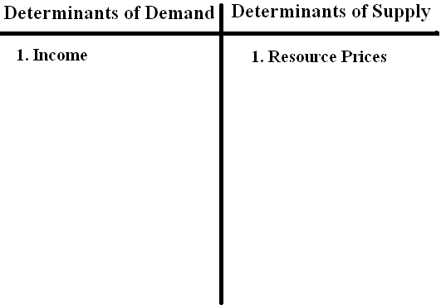

C.2 Cause and Effect
Fill in the blanks to the table with the appropriate answers. The first one is done for you.
Determinant | Does the Determinant cause a Shift? | Does it Shift Supply or Demand? | Is this Shift to the Right or to the Left? | What Happens to the Price Level? | What Happens to Quantity of Output?
Government reduces regulation on food industry. | Yes | Supply | Right | Decreases | Increases
1.Consumers fear a recession and begin to save more.
2.A trend hits the market for sporting goods.
3.The cost of steel begins to rise.
4.The government implements an import quota.
5.The price of hotdogs rise in the United States.
6.Workers gain better education levels.
7.Income tax in the United States begins to rise
8.Workers go on strike.
9.The price of wrist watches in the United States decreases.
10.Consumers expect prices to rise next month.

