Use the following to answer questions 1-6:

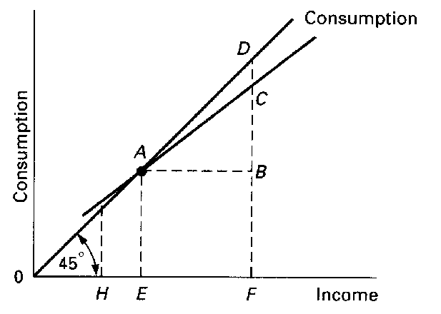

1. Refer to the above diagram. The average propensity to consume is 1 at point:

A) *F*. B) *A*. C) *D*. D) *B*.

2. Refer to the above diagram. The marginal propensity to consume is equal to:

A) *AE*/0*E*. B) *CF*/*CD*. C) *CB*/*AB*. D) *CD*/*CF*.

3. Refer to the above diagram. At income level *F* the volume of saving is:

A) *BD*. B) *AB*. C) *CF*-*BF*. D) *CD*.

4. Refer to the above diagram. Consumption will be equal to income at:

A) an income of *E*. B) an income of *F*. C) point *C*. D) point *D*.

5. Refer to the above diagram. The economy is dissaving:

A) in the amount *CD*. C) at income level *H*.

B) at all income levels greater than *E*. D) at income level *E*.

6. Refer to the above diagram. The marginal propensity to save is:

A) *CD*/*EF*. B) *CB*/*CF*. C) *CB*/*AF*. D) *EF*/*CB*.

Use the following to answer questions 7-8:



7. The above figure suggests that:

A) consumption would be $60 billion even if income were zero.

B) saving is zero at the $120 billion income level.

C) as income increases, consumption decreases as a percentage of income.

D) as income increases, consumption decreases absolutely.

8. Refer to the above figure. If the relevant saving schedule were constructed:

A) saving would be *minus* $20 billion at the zero level of income.

B) aggregate saving would be $60 at the $60 billion level of income.

C) its slope would be 1/2.

D) it would slope downward and to the right

**Answer Key:**

1. B
2. C
3. D
4. A
5. C
6. A
7. C
8. A