How China went from communist to capitalist
Frank Holmes,
U.S. Global Investors

Oct 10, 2015, 10:06 AM
China's path to capitalism. US Global InvestorsFounded in 1949 as a hardline socialist country, the People’s Republic of China has steadily embraced the tenets of capitalism, especially since economic reforms were enacted in 1978.
Today, China’s economy is the second-largest in the world and will likely overtake the U.S. sometime this century.
Explore the following slideshow to learn how China has transformed itself into an economic powerhouse, and what it aspires to achieve in the future.

Following the ideals of Karl Marx and Vladimir Lenin, Mao Tse-tung created and became the chairman of the People’s Republic of China and the Chinese Communist Party in 1949.
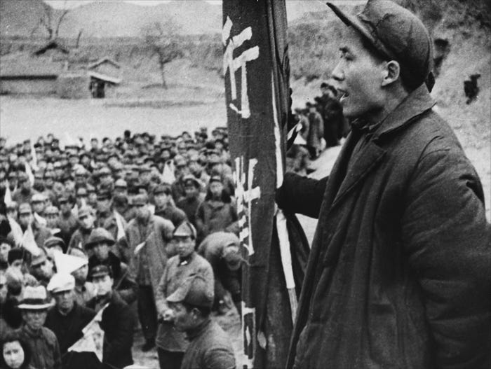
US Global Investors

Mao envisioned a society in which all would equally share in prosperity. To that end, he began to bring farms, factories and other businesses under government ownership.
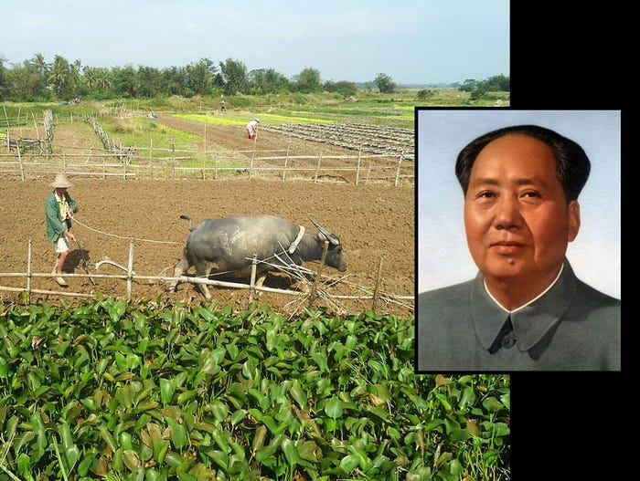
US Global Investors

Between 1959 and 1961, food production plummeted due to crop and industrial shortfalls. A great famine resulted, causing millions of deaths. The loss of privately run sectors was hurting the country tremendously.
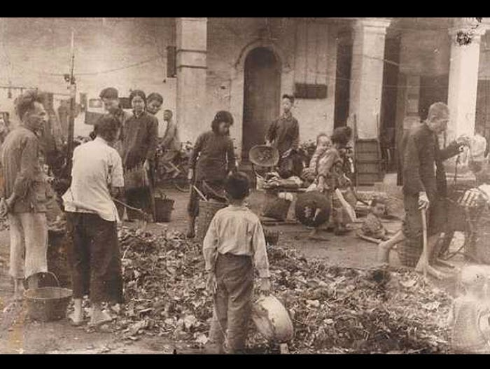
US Global Investors

In 1978, Deng Xiaoping, a Chinese revolutionary and veteran of the Communist Party, was eager to adopt capitalist methods and reforms in order to stimulate economic growth and restore confidence in the party. He and U.S. President Jimmy Carter signed an historic accord in 1979, reversing decades of China-U.S. tension.
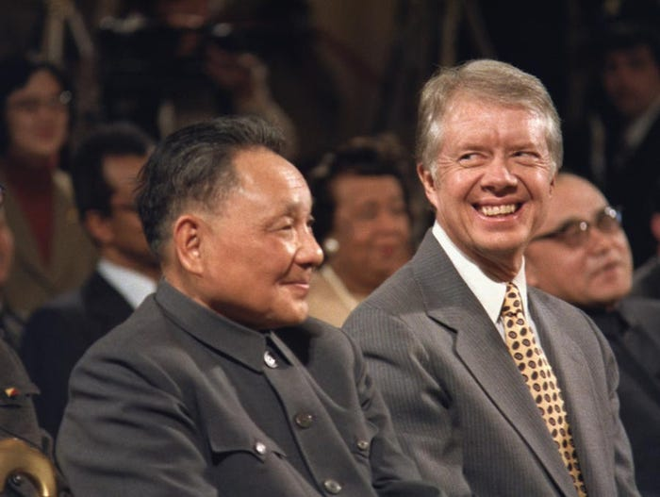
US Global Investors

Deng launched several economic reforms that allowed private sectors to start and operate their own businesses once again. He also established four special economic zones along the coast of China with intentions of attracting foreign investments.
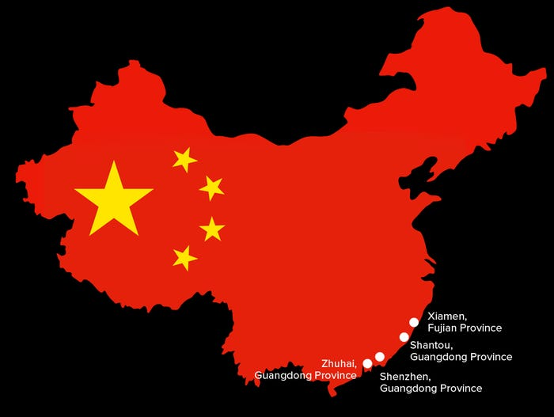
US Global Investors

Due to the reforms Deng put in place, China has gone from being a country that opposed capitalism to one that embraces property rights, profits and free market competition.
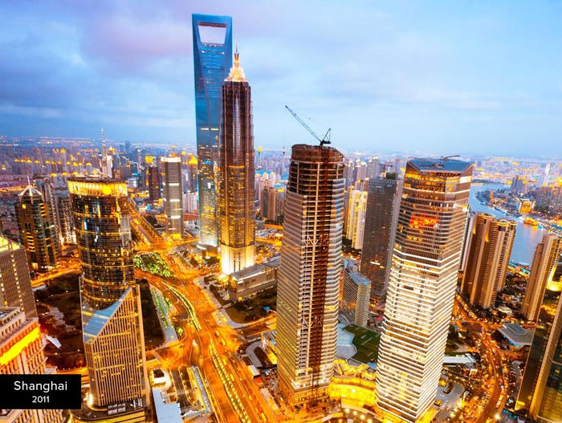
US Global Investors

Today, in 2015, the Shanghai Stock Exchange is the third-largest in the world by market capitalization.
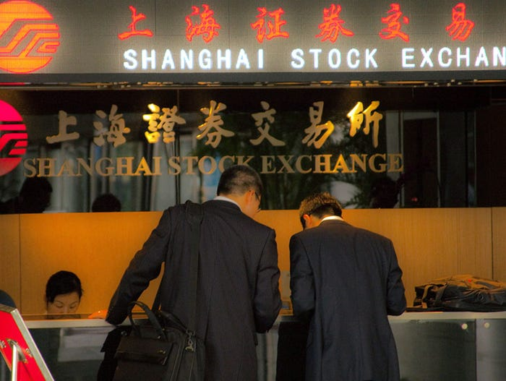
US Global Investors

The Asian giant is a commodities powerhouse, importing over half of the world’s annual consumption of aluminum, and nearly half of its nickel, copper, zinc, tin and steel.
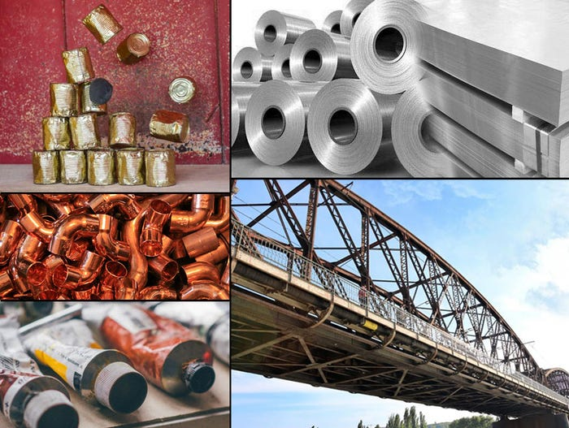
US Global Investors

China has entered into a number of regional and bilateral trade agreements, or is in the process of doing so. It currently has free trade agreements with the Association of Southeast Asian Nations (ASEAN), Chile, Costa Rica, Hong Kong, Iceland, Macau, New Zealand, Pakistan, Peru, Singapore and Switzerland.
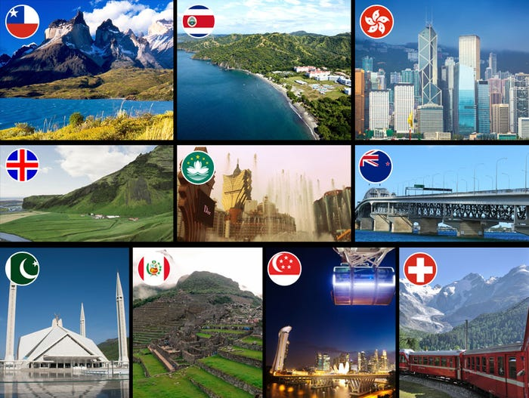
US Global Investors

The country is in the process of transforming itself from a global center of low-tech manufacturing into a major hub of innovation and consumption.
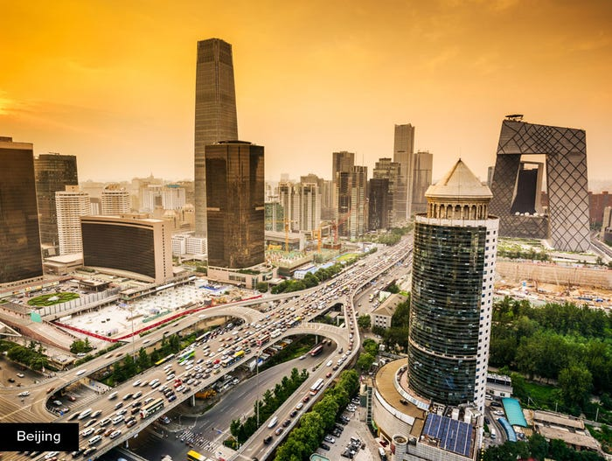
US Global Investors

Global institutions, including the International Monetary Fund (IMF) and World Bank, have endorsed a new China-led international bank, the Asian Infrastructure Investment Bank (AIIB).
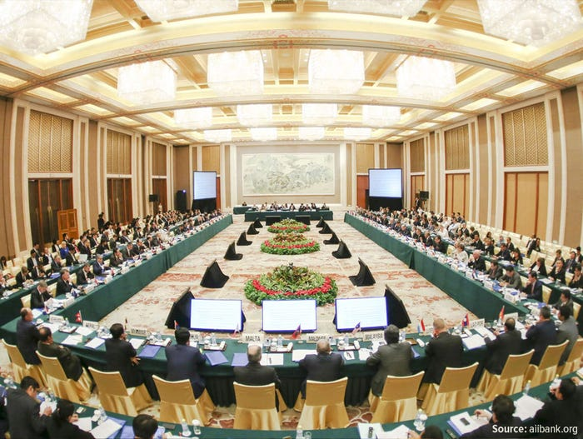
US Global Investors

China hopes to see its currency, the renminbi, become a world-class reserve currency to compete with the U.S. dollar. As such, its central bank has been building up its gold reserves.

